This brief document outlines the three main issues that need to be resolved with the Science Library in order to make it usable beyond the original NIS ITA program:

# Issue 1: Handle different paper statuses

In the current solution we do not make use of the existing status property on the document concept. This means that all papers are implicity treated as “accepted” and we do not have a mechanism for distinguishing papers that are in “submitted” only status.

## Proposed solution

1. Add a new column to the spreadsheet to allow the paper status to be specified.
2. Add a mechanism on the dashboard to say whether to generate only "accepted" papers or all papers regardless of status.
3. For delivery to the public site(s) it will only be accepted papers that are generated but you can easily generate submitted papers too and show them locally.
4. A small update to the UI to highlight if a paper is submitted or any other non-accepted status (e.g. when listing it and when showing the details).

This means all papers (accepted, submitted and any other status we come up with) will always be in the spreadsheet but we can choose whether to push them to the science library or not (e.g. never to the live one but probably to a local test/review one).

When papers change status you just edit and save the spreadsheet - no need to track dates and historical statuses etc.

# Issue 2: Need to handle multiple programs

Currently all papers in the Science Library are assumed to be for a single program (NIS ITA was the original program). In order for the Science Library to be used more widely the ability to mark a given paper as relating to a specific program, and the ability for papers covering multiple programs is required.

## Proposed solution

1. Add a new column into the spreadsheet (and corresponding CE property) to contain the name of the program.
2. For the ITA this will always be "ITA" and for NS-CTA it will always be "NS-CTA" but for the branch solution it may be many values.
3. Add a new CE concept (and spreadsheet tab) to allow extra properties to be defined for programs if needed (e.g. start date, end date, leaders, url etc)
4. Update the UI so that if only one program is loaded then there is no change from current behaviour, but if there are > 1 programs then you get a drop down list in the header area allowing you to switch the UI between different programs. This keeps it simple: You can only ever see one program at a time but you can easily switch between them.

# Issue 3: Cannot handle authors who change organisations

In the current model the link between person and organisation is universal and it does not allow for situations where a single person authors papers for different organisations.

The solution to this is fairly simple and is described in detail below:

## Current model

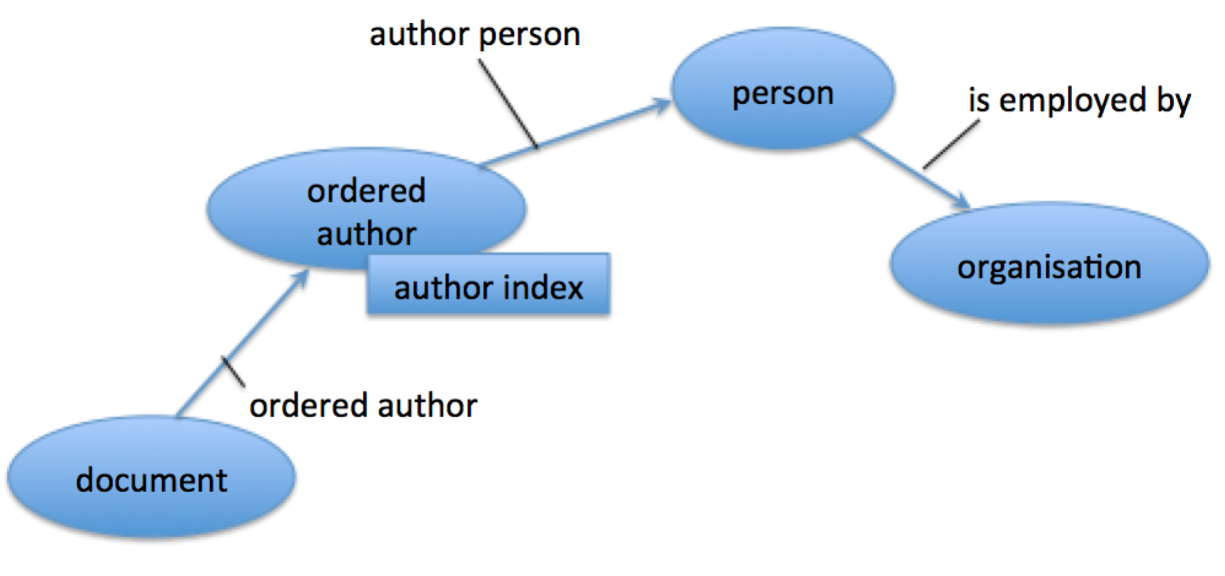

* Every document->person relationship is captured as an ordered author because we need to retain the knowledge of the author index (the relative position that author had in the list of authors for the paper).  
  This relationship is defined in the spreadsheet.
* Every person is linked to a single organisation via the is employed by relationship, regardless of what they claim their affiliation as in each paper.  
  This relationship is defined in the spreadsheet
* This means that even if you link a single person to more than one organisation you cannot know which documents were authored using which organisation.

## Proposed change

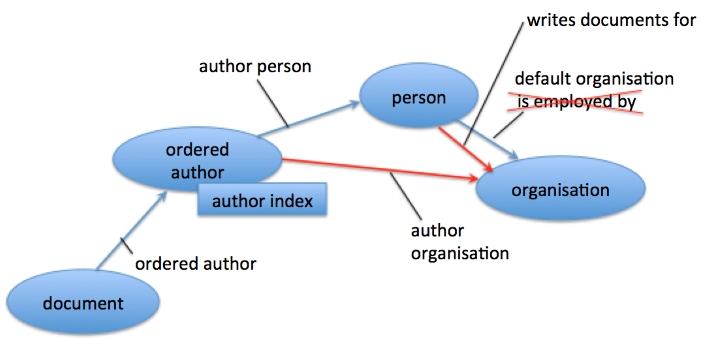

* Add new columns into the spreadsheet to optionally allow the author organisation to be specified alongside the existing author person.
* Add a new relationship from ordered author to organisation named author organisation.
* This enables the organisation to be captured for every person who authors every document and means that the knowledge of the affiliation for each author of every document is captured regardless of how many times it changes between documents.
* Change the name of the is employed by relationship to be default organisation – this is now used only for those persons who only ever are affiliated to one organisation.
* Add a new relationship between person and organisation named writes document for. This will be populated by a new rule that says if an ordered author has an author person and an author organisation then that person writes documents for that organisation.
* Write a new rule that infers the author organisation for every ordered author only if the person has a default organisation. This saves manually maintaining all this data in the spreadsheet for every author (since many persons only ever have only one organisation).
* For persons who write documents for more than one organisation we remove the default organisation link (in the spreadsheet) and insist that every time that person is added as an author in the spreadsheet that the organisation they are authoring for must be specified (in the new columns mentioned earlier).
* This means the following:

1. The spreadsheet need only specify organisations for authors that change affiliations.
2. The ce-store computes a list of all organisations that a person writes documents for.
3. The ce-store uses the default organisation relationship to allow many of the author organisations to be inferred automatically.
4. We now know the author and their affiliation for every document in the science library and we have full control over configuring that via the spreadsheet.